**Practice Tasks : Evaluation in next Lecture**

**Task#1: Execute lab1.py and describe your observations.**

**Task#2**: Use the given below images as your input images and perform all arithmetic and logical operations. Show your code and also state your observations for each.



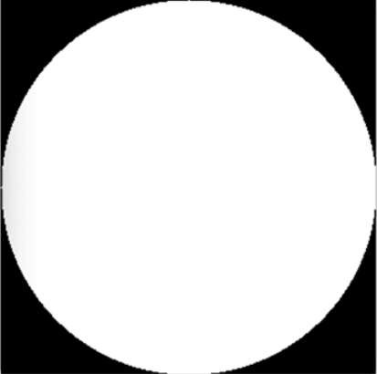

**Task#3:** Capture your image through webcam and save it. You may use code given in CaptureVideoImage.py.

**Task#4:** Perform all the types of flipping on the captured image. Show the flipped images. **Task#5:** Perform all rotations on the captured image. Show the rotated images.

**Task#6**:

1. Concatenate the original and flipped images into 1 image.
2. Similarly concatenate all the rotated images into 1 image.

**Task#7:** Execute read.py and describe your observations.

**OpenCV help functions and their description is given on the next page.**

### Flip:

We can flip an image around either the x-axis, y-axis, or even both. Basic Syntax is :

flipped = cv2.flip(image, value)

Value is 1 for horizontal flipping. Value is 0 for vertical flipping. Value is -1 for both axis.

### Rotate:

cv2.rotate() method is used to rotate a 2D array in multiples of 90 degrees. The function cv::rotate rotates the array in three different ways.

1. Rotate by 90 degrees clockwise:

cv2.rotate(image to be rotated, cv2.ROTATE_90_CLOCKWISE)

1. Rotate by 180 degrees clockwise: cv2.ROTATE_180
2. Rotate by 270 degrees clockwise : cv2.ROTATE_90_COUNTERCLOCKWISE

### Concatenation of images:

To concatenate images vertically and horizontally with Python, cv2 library comes with two functions as:

1. **hconcat():** It is used as cv2.hconcat() to concatenate images horizontally. Here h means horizontal. cv2.hconcat() is used to combine images of same height horizontally.
2. **vconcat():** It is used as cv2.vconcat() to concatenate images vertically. Here v means vertical. cv2.vconcat() is used to combine images of same width vertically.

### Arithmetic and Logical Operators- Bitwise AND, OR, NOR, XOR

#### Arithmetic Operations like Addition, Subtraction, and Bitwise Operations(AND, OR, NOT, XOR) can be applied to the input images

1. Addition
2. Subtraction

#### Bitwise operations are used in image manipulation and used for extracting essential parts in the image. In this article, Bitwise operations used are:

1. Bitwise AND
2. Bitwise OR
3. Bitwise XOR
4. Bitwise NOT
   1. **Addition**

* Syntax: cv2.add(img1, img2)

But adding the pixels is not an ideal situation. So, we use cv2.addweighted(). Remember, both images should be of equal size and depth.

* Syntax: cv2.addWeighted(img1, wt1, img2, wt2, gammaValue)

Parameters:

* + img1: First Input Image array(Single-channel, 8-bit or floating-point)
  + wt1: Weight of the first input image elements to be applied to the final image
  + img2: Second Input Image array(Single-channel, 8-bit or floating-point)
  + wt2: Weight of the second input image elements to be applied to the final image
  + gammaValue: Measurement of light
  1. **Subtraction of Image:**

Just like addition, we can subtract the pixel values in two images and merge them with the help of cv2.subtract(). The images should be of equal size and depth.

Syntax: cv2.subtract(image1, image2)

* 1. **AND:** A bitwise AND is true *if and only if* both pixels are greater than zero.
  2. **OR:** A bitwise OR is true *if either* of the two pixels is greater than zero.
  3. **XOR:** A bitwise XOR is true *if and only if* one of the two pixels is greater than zero, *but not both.*
  4. **NOT:** A bitwise NOT inverts the <on= and <off= pixels in an image.

**Syntax:**

bitwiseAnd = cv2.bitwise_and(rectangle, circle) bitwiseOr = cv2.bitwise_or(rectangle, circle) bitwiseXor = cv2.bitwise_xor(rectangle, circle) bitwiseNot = cv2.bitwise_not(circle)